Fine needle aspiration biopsy  What is aspiration biopsy?  A biopsy is sampling of an abnormal area of tissue growth such as a nodule in the thyroid, a lump in the salivary gland or an enlarged lymph gland. Sampling by aspiration biopsy is similar to sampling blood from a vein in your arm, except the needle is thinner. The needle is inserted into the lump and a drop of semisolid material withdrawn for testing.  Why use Austpath for your biopsy?  All biopsies are performed by Dr Edward Chandraratnam. He has been practicing the procedure for over 20 years and is a recognised expert in fine needle aspiration biopsy. We use ultrasound to accurately target the lump ensuring a much higher rate of successful tissue extraction. The sample is checked immediately for adequacy. This means, if the sample is not sufficient for diagnosis, another sample is taken immediately. If Dr Chandraratnam feels that additional samples will be needed for other tests, they can be taken immediately, and you won't have to return for another biopsy.  What is involved in the procedure?  Dr Chandraratnam will perform an ultrasound of the lump and record its size and exact location. This ensures that you and your doctor know exactly what was biopsied. To ensure that sampling is representative, more than one sample may be required, from different areas of the lump; this is required when there is a large or complex lesion, or in a lump that contains few cells. The biopsy is then checked immediately to ensure that an adequate sample has been obtained.  Is the procedure painful?  We numb your skin with very cold air before the biopsy using Zimmer Cryo 6. This reduces the pain, bleeding and bruising which may occur after the procedure. However you will feel pressure on neck and some discomfort as the needle is moved to obtain the tissues for the biopsy. |  | How do I prepare for the procedure?  Are you taking medication?  When you make your appointment, you need to let us know if you are taking any blood thinning medication. It is very important that you do not stop any of these medications or change the dose without consulting your own doctor and Dr Chandraratnam.  Do I need to fast?  You can eat and drink normally before and after the procedure  How long does the procedure take?  The procedure generally takes up to half an hour but can be longer if the biopsy is complex., Following the procedure you should wait for a short period in our recovery room to ensure there are no side-effects. You are generally allowed to resume normal, but non-strenuous, activities for the rest of the day.  Are there any after effects?  It is common to have some pain, swelling and even a little bruise where the needle was inserted. Cold compress and analgesics such as paracetamol (E.g., Panadol, Tylenol) can be used to relieve pain. Please avoid analgesics containing aspirin or ibuprofen. Pain and swelling should be minimal after 48 hours.  When will my results be available?  Your biopsy results are sent directly to your referring doctor. We will send you a text message 48 hours after the results have been sent to your doctor. Your results will also be available on your “My Health Record” within seven to ten days. Please contact your doctor to discuss the biopsy results, what they mean, and what should be done next.  Are you having second thoughts?  Most patients look upon aspiration biopsy as they would a blood test, however some may put off scheduling the biopsy, or fail to keep an appointment. This may be due to a fear of needles or of what the biopsy may find. Rather than risk delay in your diagnosis, we urge you to make and keep your appointment with us. You have our assurance that your questions will be answered in clear and easy to understand language. If, after this discussion, you still do not desire the biopsy, we will respect your decision.

- Reminder
We will send you a reminder one day before your appointment

- On the day of your procedure
Bring your referral and any other information your doctor may have given to you. We also recommend you bring someone with you to accompany you home.

- Transport to Austpath
There is off street patient parking on the premises. If you are using public transport buses are available from Westmead Train Station.

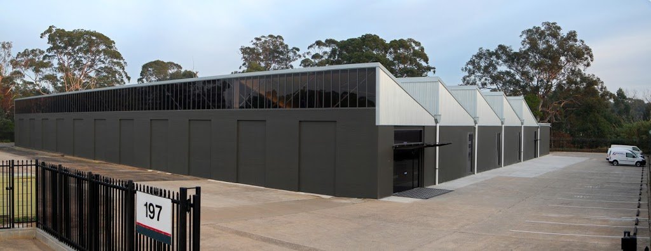
- Medical certificates
If you require a medical certificate please advise our receptionist on arrival (before the biopsy).

- Photography
To protect your privacy, and the privacy of other patients, no photography or video recording is permitted in the biopsy room.

- Privacy policy
Our privacy statement is available on our website: www.austpath.com.au

- Do you need any more information
If you need any further information you can contact our practice manager:
T: 02 8836 3333
E: practicemanager@austpath.com.au
Page 2

